# **Deployment Report**

# **TS Micro App Deployment on AWS EC2 Instance**

**Project overview:**

This involved Hosting TS Micro App, a web application. Both frontend and backend components were the part of deployment.

**AWS Account Creation:**

* The deployment process first step was the creation of an AWS account.
* This step required signing up, provide payment information and select a plan, hence a free plan was chosen.

**EC2 Instance Creation:**

This step was a bit complex as it started from navigating to the instance section and creating an instance by clicking the **Launch Instance** option.

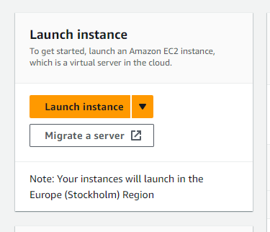

Launched the instance after selecting the AMI and naming the instance.

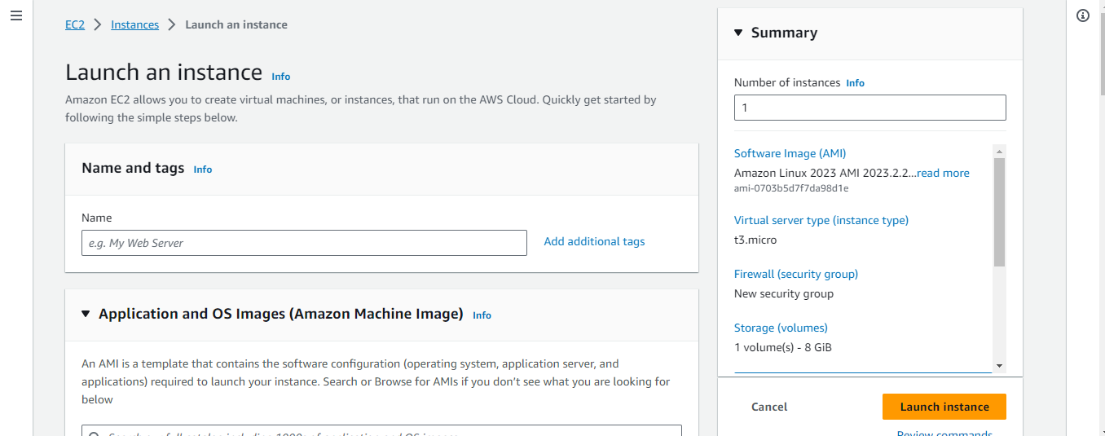

**2. Backend and Frontend Code Setup:**

Cloned the project repository onto the EC2 instance and performed further commands including necessary dependencies and build tools were installed.

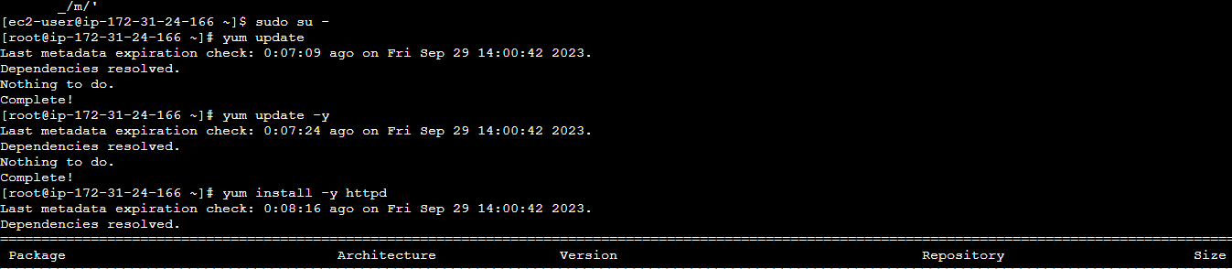

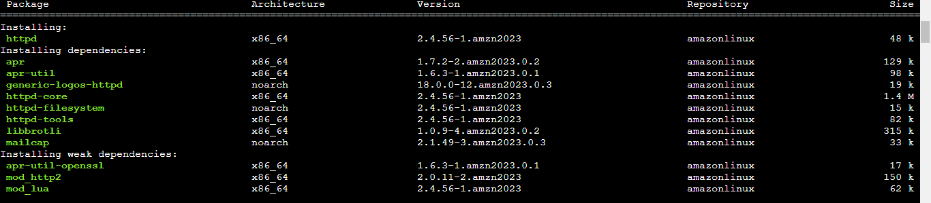

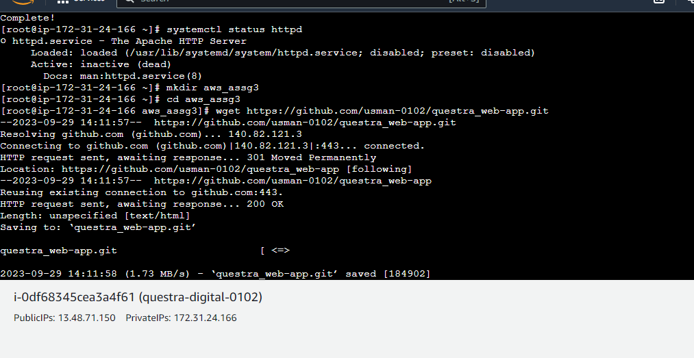

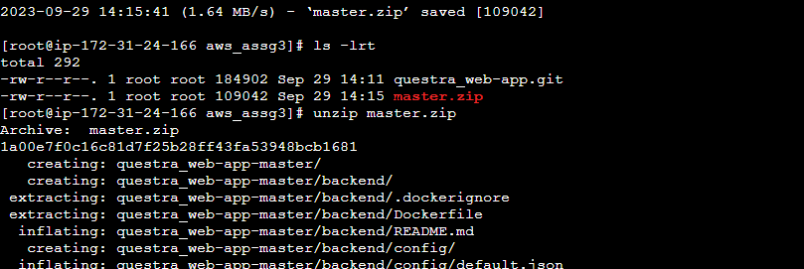

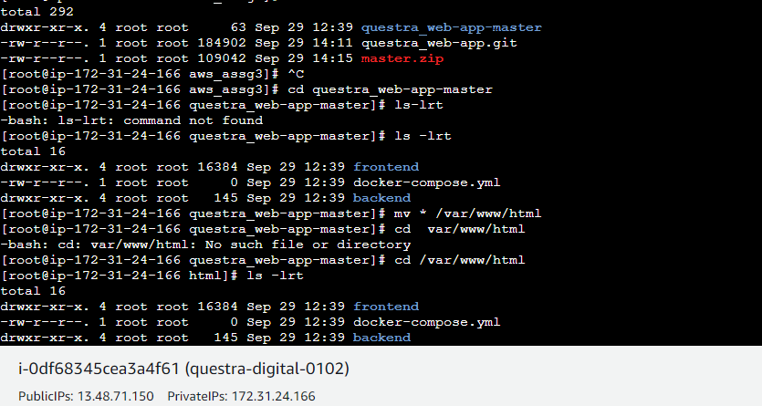

Enabled the systemctl and started the httpd server

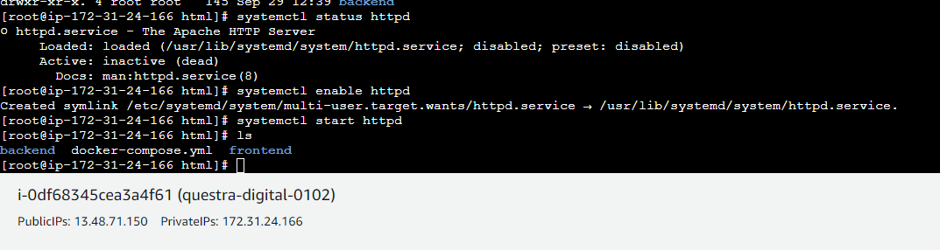

The server was setup and the application ran.

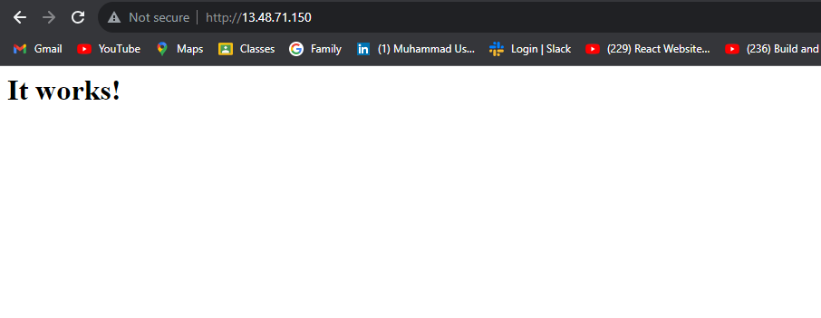

**Conclusion:**

In conclusion, the deployment of the web application to AWS was successfully completed. This involved creating an AWS account, configuring a web application with specific settings, and deploying the project's code to the AWS platform using EC2 instances.